Prelab:
In this lab, you will be controlling the speed and direction of rotation for a DC motor. The ardunio digital pins don’t have sufficient power to run the motor directly, so a motor driver integrated circuit is used. In this case, we will be using a DRV8835 dual motor driver whose datasheet is posted on mycourses. The driver IC is placed on a driver module board, called the motor driver carrier with the pinout provided in figure 1. A description of how the driver works is provided in the datasheet for the motor driver carrier board.

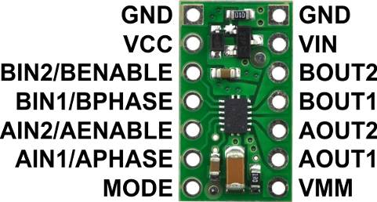
Figure 1. DRV8835 Dual Motor Driver Carrier
With the motor driver chip, it is possible to turn the motor forward or backwards just by setting the PWM signals sent to the driver. In the lab, you’ll be using a timer to set up and vary two PWM signals. When the PWM signals are both 50% the motor is still. When one PWM signal is 25% and the other 75%, the motor turns forward, and vice versa when the PWM signals are reversed, the motor direction changed.

Prelab tasks:
- Read the DRV8835 Dual Motor Driver Carrier Datasheet as posted on mycourses.
- Skim read the datasheet for just the IC (DRv8835) to get a general idea of what the motor control IC does.
- Complete the pre-lab questions at the end of this handout.
- The driver IC carrier printed circuit board must be soldered onto your uC expansion board as shown in figure 2. Follow the separate video instructions for building the board.
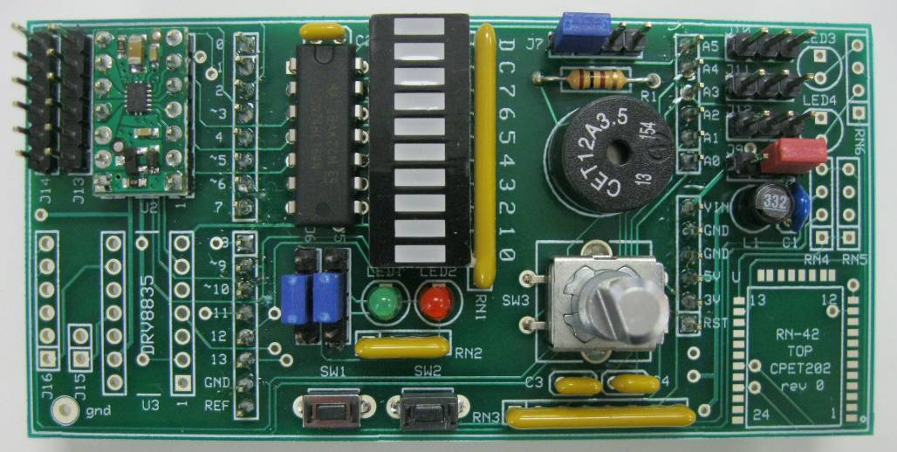
Figure 2. CPET-202 board with motor driver carrier and knob encoder installed.

- Prior to lab, examine the schematic below and note the following elements:
- The rotary encoder on page 2 of the schematic has two switch signals A and B which are connected to the inputs A1 and A0, respectively. The switch signals A and B have 4.7kOhm pullup resistors connected to them and also have an R-C filter connected to them to reduce switch bounce. When the metal shaft of the encoder is turned, the A and B switches open and close in a particular pattern which allows the microcontroller to determine whether the shaft is being turned clockwise or counter-clockwise. The other signal of interest is the switch connected from terminals S1 to S2. This switch is closed when the shaft of the encoder is pressed down. The S2 terminal is grounded while the S1 terminal is connected to Arduino pin A2. This switch input will require an input pullup to be configured in the Arduino code.
- The two wire connector goes to J14, where motor wires Y1 and Y2 are connected. Pin 1 on this header will go the orange motor lead. Pin 2 goes to the purple motor lead. See figure 3 and detail figure 4.
- The three wire connector we will call Servo2/QTR2 goes to J11. This connects a QTR-2 reflectance sensor to Arduino analog input pin 4. This signal indicates if the sensor sees a white object or a black object. The black wire of the connector goes towards the center of the board, as shown in figure 3 and detail figure 4.

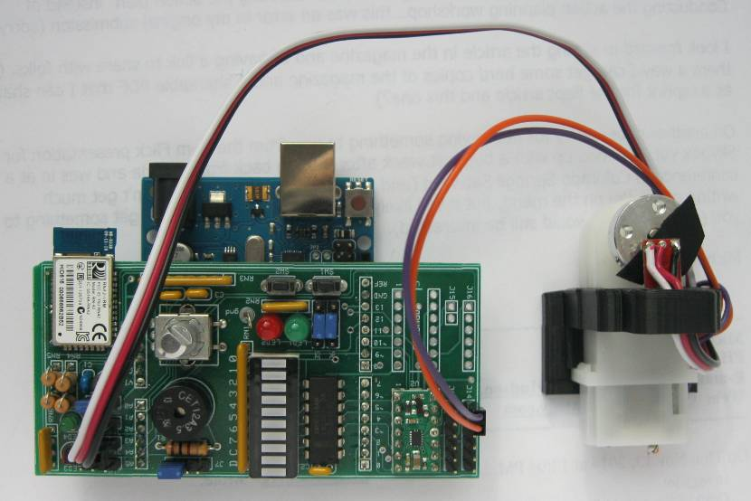
Figure 3. DC motor with reflectance sensor connected to motor driver circuit board.

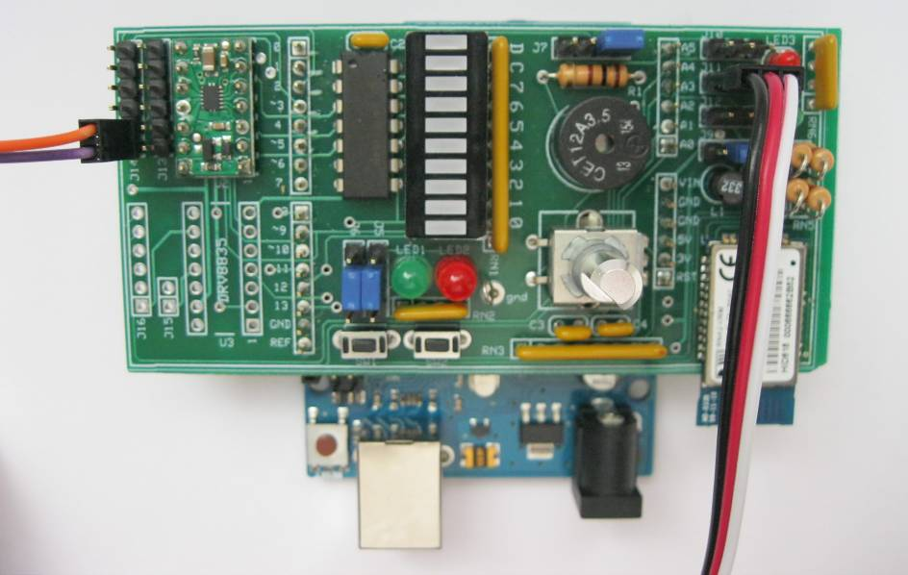
Figure 4. Detail of reflectance sensor and motor wire connections.

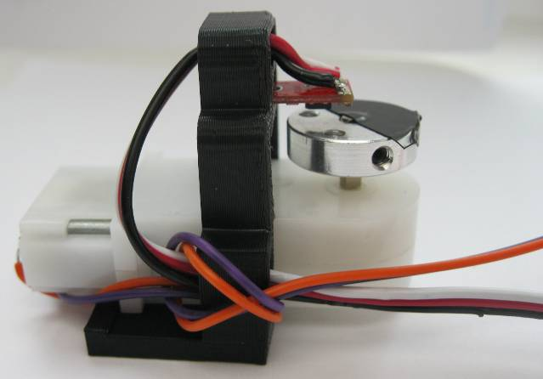
Figure 5. DC Motor with reflectance sensor mounted above half black/white disk

Shown in figure 5, the dc motor (white plastic) has a round disk on it with a half black, half white circular pattern. The reflectance sensor puts out can detect the light or dark region either as an analog level or a simple digital on/off level. The schematic of the reflectance sensor is shown in figure 6.

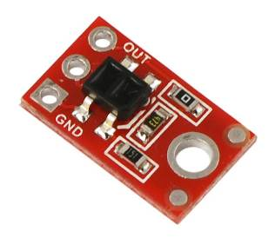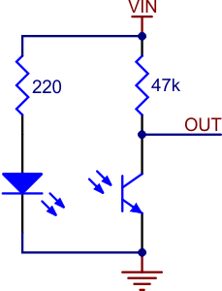
Figure 6. QTR-1A reflectance sensor schematic.

When light from the LED is reflected off a surface and back into the phototransistor, the transistor turns on and the OUT pin goes low.
When there is no light from the LED reflected back to the phototransistor, the 47k pullup resistor causes the OUT pin to go HIGH.
Therefore, the black portion of the disk will cause a digital HIGH signal. The white portion of the disk will cause a digital LOW signal from the reflectance sensor.
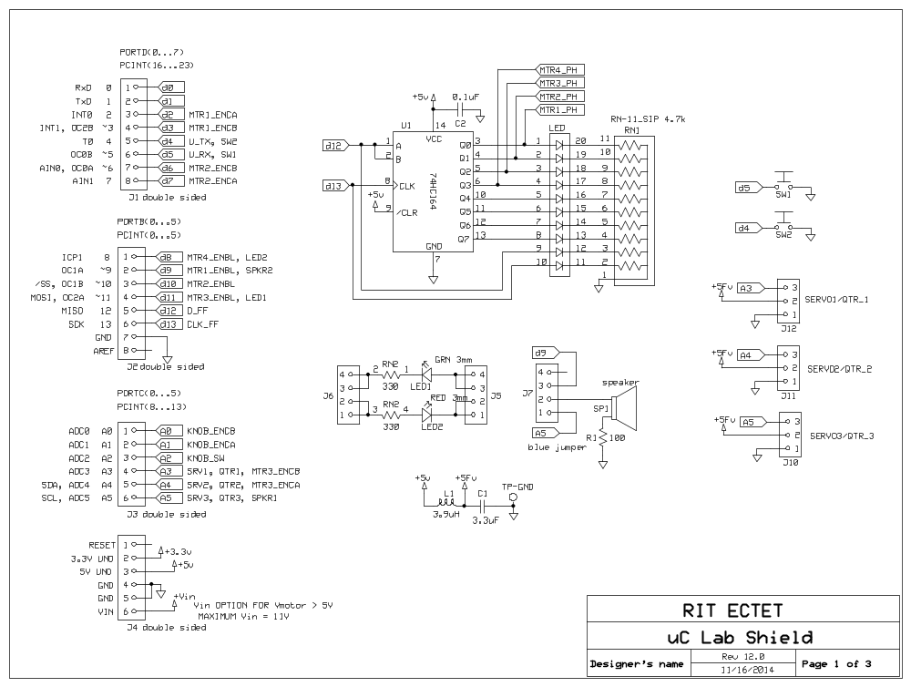
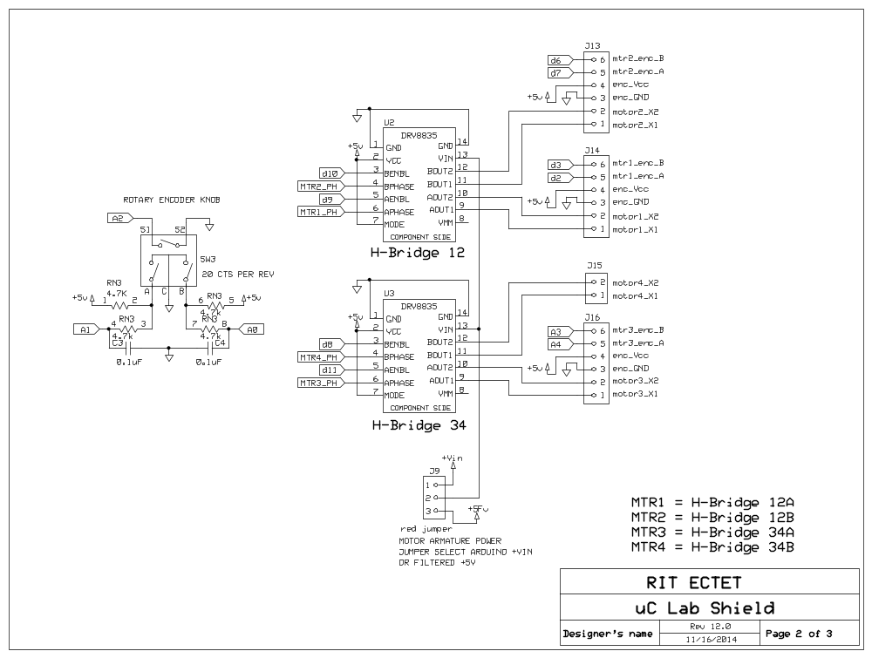

Date: __________________________

Name: __________________________

Pre-lab questions that must be answered before receiving motor hardware.

- From the PCB schematic, what “mode” is the motor driver being run in?
(you’ll need to read the DRV8835 Dual Motor Driver Carrier Datasheet to answer this).

- From the schematic, what is the name of the Arduino pin where the PWM value is provided to motor A on H-bridge12?

- From the schematic, what is the name of the Arduino pin that reads the reflectance sensor (QTR-2)?

- From the ATMEL 328 datasheet, page 2, for the 28 pin DIP package, what are all the pin names/pin functions for Arduino pin 9.

- Write out the register values (as listed below) to configure Timer 1 to produce fast PWM (mode 14) with the COM1A bits configured to clear on compare, with a switching frequency at 20 kHz, with a clock prescale divisor of 1, and a duty cycle of 25% on OC1A.

TCCR1A (binary) =

TCCR1B (binary) =

OCR1A (decimal) =

ICR1 (decimal) =

